**1. Create a program that reads the length and width of a farmer’s field from the user in feet.  Display the area of the field in acres. Hint: There are 43,560 square feet in an acre. Sample Input 1000 1000**

**Sample Output 22.95684113865932 acres**

**Program:**

import java.util.Scanner;

public class FieldArea {

public static void main(String[] args) {

Scanner scanner = new Scanner(System.in);

System.out.println("Enter the length and width of the field in feet:");

double length = scanner.nextDouble();

double width = scanner.nextDouble();

double areaInSquareFeet = length * width;

double areaInAcres = areaInSquareFeet / 43560;

System.out.println(areaInAcres + " acres");

}

}

**Output:**

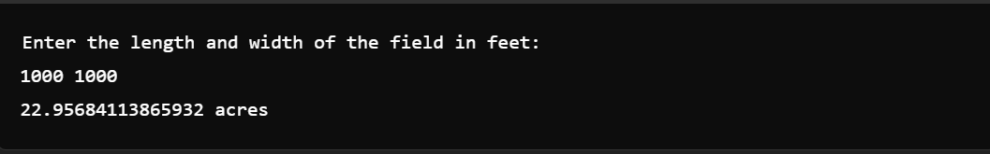

**2. An online retailer sells two products: widgets and gizmos. Each widget weighs 75 grams. Each  gizmo weighs 112 grams. Write a program that reads the number of widgets and the number of  gizmos from the user. Then your program should compute and display the total weight of the  parts.**

**Sample Input: 10 20**

**Sample Output: The total weight of all these widgets and gizmos is 2990 grams.**

**Program:**

import java.util.Scanner;

public class TotalWeight {

public static void main(String[] args) {

Scanner scanner = new Scanner(System.in);

System.out.println("Enter the number of widgets and gizmos:");

int widgets = scanner.nextInt();

int gizmos = scanner.nextInt();

int totalWeight = widgets * 75 + gizmos * 112;

System.out.println("The total weight of all these widgets and gizmos is " + totalWeight + " grams.");

}

}

**Output:**

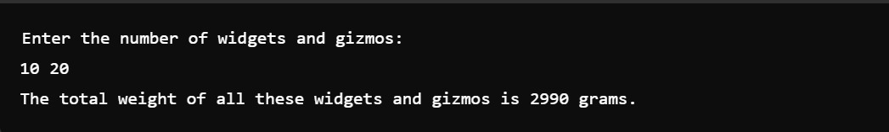

**3. In many jurisdictions, a small deposit is added to drink containers to encourage people to recycle  them. In one particular jurisdiction, drink containers holding one liter or less have a $0.10  deposit and drink containers holding more than one liter have a $0.25 deposit. Write a program  that reads the number of containers of each size(less and more) from the user. Your program  should continue by computing and displaying the refund that will be received for returning  those containers. Format the output so that it includes a dollar sign and always displays exactly  two decimal places.**

**Sample Input 10 20**

**Sample Output Your total refund will be $6.00.**

**Program:**

import java.util.Scanner;

public class ContainerRefund {

public static void main(String[] args) {

Scanner scanner = new Scanner(System.in);

System.out.println("Enter the number of containers holding one liter or less and more than one liter:");

int smallContainers = scanner.nextInt();

int largeContainers = scanner.nextInt();

double totalRefund = smallContainers * 0.10 + largeContainers * 0.25;

System.out.printf("Your total refund will be $%.2f\n", totalRefund);

}

}

**Output:**



**4. Write a program to find whether the given input number is Odd. If the given number is odd,  the program should return 2 else It should return 1.**

**Program:**

import java.util.Scanner;

public class OddCheck {

public static void main(String[] args) {

Scanner scanner = new Scanner(System.in);

System.out.println("Enter a number:");

int number = scanner.nextInt();

if (number % 2 != 0) {

System.out.println(2);

} else {

System.out.println(1);

}

}

}

**Output:**

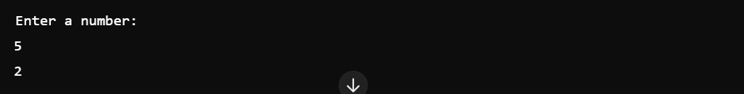

**5. Write a program that returns the last digit of the given number. Last digit is being referred to  the least significant digit i.e. the digit in the ones (units) place in the given number. The last  digit should be returned as a positive number.**

**For example,**

**if the given number is 197, the last digit is 7. if the given number is -197, the last digit is 7**

**Program:**

import java.util.Scanner;

public class LastDigit {

public static void main(String[] args) {

Scanner scanner = new Scanner(System.in);

System.out.println("Enter a number:");

int number = scanner.nextInt();

int lastDigit = Math.abs(number) % 10;

System.out.println(lastDigit);

}

}

**Output:**

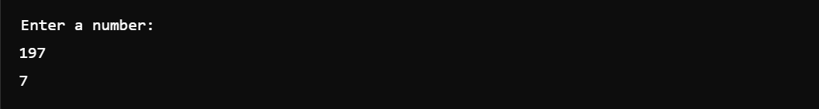

**6. Rohit wants to add the last digits of two given numbers.**

**For example,**

**If the given numbers are 267 and 154, the output should be 11.**

**Below is the explanation:**

**Last digit of the 267 is 7**

**Last digit of the 154 is 4**

**Sum of 7 and 4 = 11**

**Write a program to help Rohit achieve this for any given two numbers.**

**Note: Tile sign of the input numbers should be ignored.**

**if the input numbers are 267 and 154, the sum of last two digits should be 11 if the input numbers are 267 and -154, the slim of last two digits should be 11 if the input numbers are -267 and 154, the sum of last two digits should be 11 if the input numbers are -267 and -154, the sum of last two digits should be 11**

**Program:**

import java.util.Scanner;

public class LastDigitSum {

public static void main(String[] args) {

Scanner scanner = new Scanner(System.in);

System.out.println("Enter two numbers:");

int number1 = scanner.nextInt();

int number2 = scanner.nextInt();

int lastDigit1 = Math.abs(number1) % 10;

int lastDigit2 = Math.abs(number2) % 10;

int sum = lastDigit1 + lastDigit2;

System.out.println(sum);

}

}

**Output:**

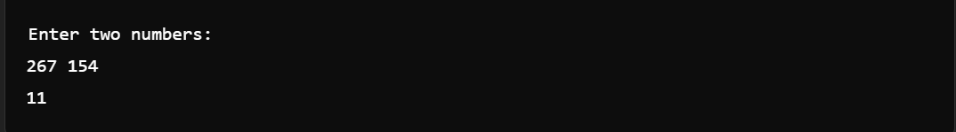

**7. Complete the program to convert days into years, month and days. (Ignoring leap year and  considering 1 month is 30 days)**

**Input 375 Output YEARS: 1 MONTH: 0 DAYS: 10**

**Input 200 Output YEARS: 0 MONTH: 6 DAYS: 20**

**Program:**

import java.util.Scanner;

public class DaysConversion {

public static void main(String[] args) {

Scanner scanner = new Scanner(System.in);

System.out.println("Enter the number of days:");

int days = scanner.nextInt();

int years = days / 365;

days %= 365;

int months = days / 30;

days %= 30;

System.out.println("YEARS: " + years + " MONTHS: " + months + " DAYS: " + days);

}

}

**Output:**

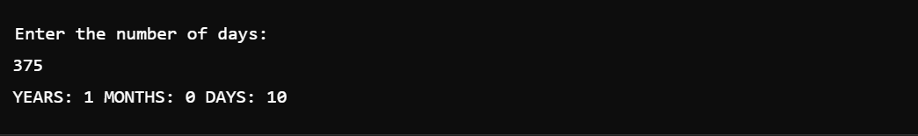

**8. Write a program that returns the second last digit of the given number. Second last digit is  being referred 10the digit in the tens place in the given number. For example, if the given  number is 197, the second last digit is 9. Note1 - The second last digit should be returned as a  positive number. i.e. if the given number is -197, the second last digit is 9. Note2 - If the given  number is a single digit number, then the second last digit does not exist. In such cases, the  program should return -1. i.e. if the given number is 5, the second last digit should be returned  as 0.**

**Program:**

import java.util.Scanner;

public class SecondLastDigit {

public static void main(String[] args) {

Scanner scanner = new Scanner(System.in);

System.out.println("Enter a number:");

int number = scanner.nextInt();

number = Math.abs(number);

if (number < 10) {

System.out.println(-1);

} else {

int secondLastDigit = (number / 10) % 10;

System.out.println(secondLastDigit);

}

}

}

**Output:**

